Wave buoy design project

University of Exeter (Falmouth Campus) and Falmouth University collaboration

George Crossley, Henry Eaton, Ian Ashton, Ajit Pillai

# Summary

Production of a low cost wave measurement buoy, for cost effective, simple deployment at sea.

The device is required to measure wave height, period and direction for a minimum of 1 month and is not required to transmit real time data to shore.

# Measurement unit

## Hardware

Arduino, MRU 6 degrees of freedom motion pack.

## Software

### Data capture

**Motion** data is saved to ‘IMU.csv’ on the SD card at approximately 20Hz. Motion data includes: Milliseconds, roll, pitch, yaw, rate of roll (ror), rate of pitch (rop), rate of yaw (roy), acceleration in x (ax), acceleration in y (ay), acceleration in z (az), compass x (cx), compass y (cy), compass z (cz).

**Position** data is saved to ‘GPS.csv’ on the SD card once every minute. Position data is stored as NMEA sentences.

### Data processing

Displacement in horizontal (x,y) and vertical (z) direction (surge, sway and heave) is calculated by integrating accelerations in the x, y and z directions whilst compensating for roll, pitch and yaw.

# Housing design criteria

1. MEASUREMENT UNIT - The housing must contain the motion unit and batteries and these must stay dry. Dimensions given in Appendix 5.2. The buoy must therefore have an opening through which to access the unit to remove the SD card and replace batteries which must be sealed and able to withstand a harsh marine environment.
2. SHAPE - The wetted area should be shaped such that the response from waves in all directions is symmetrical. This is likely to comprise a semi-spherical shape. The software will compensate for roll, pitch and yaw motions when calculating displacement in horizontal and vertical directions. The roll pitch and yaw motions should be limited where possible, but allow completely free movement in other degrees of freedom. This partly the job of the mooring system, as mentioned in section 4.
3. SIZE – compromise between visibility and mass including mooring (consider ease of installation)
4. COLOUR - The housing must be bright yellow with weatherproof, long-lasting plastic or coating
5. MOORING - The housing must have a robust mooring connection point (determine maximum drag and apply significant safety factor). The housing must have sufficient buoyancy to support the mooring system, whilst remaining visible on the surface.
6. GPS TRANSMISSION - The GPS receiver must not be inhibited. Some investigation required – it is assumed that the signal will pass best through a clear plastic, but potentially require a waterproof cable hole for the antenna cable.
7. No data transmission is required at this stage.

Buoys previously and currently used by the University of Exeter Renewable Energy department can be seen in Appendix 5.1.

# Mooring

Many wave measurement buoy mooring systems incorporate rubber bungee allowing the buoy greater freedom of movement. These are expensive, susceptible to damage and perishable. Larger buoys with high buoyancy can support greater lengths of mooring chain/rope/bungee. Smaller buoys will often not have sufficient buoyancy to support a large mooring system (e.g. 50m) and as such auxiliary buoys as seen in Figure 1 provide a practical solution, allowing a lightweight system, with suitable freedom of movement and the added advantage of greater visibility.

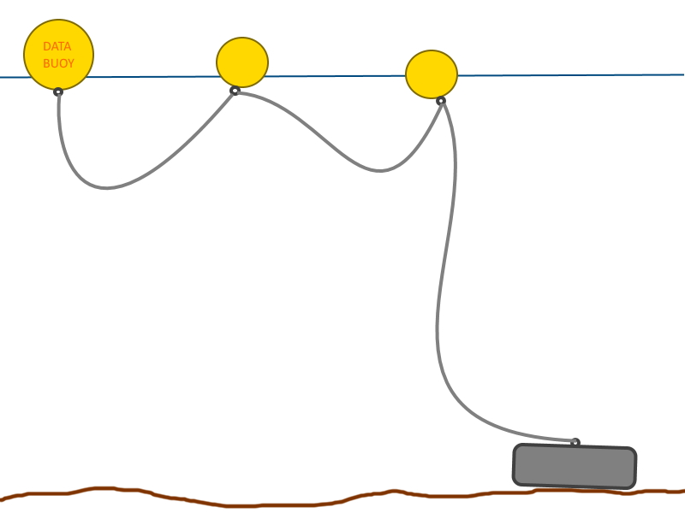

Figure 1: Overview of lightweight, flexible mooring system configuration

# Appendix

## Existing wave measurement buoys

Some specifications & dimensions can be found on the web-pages for each buoy.

|  |  |  |
| --- | --- | --- |
|  | Image result for spotterbuoy |  |
| Datawell | Spotter | Fugro Seawatch |
| <http://www.datawell.nl/Portals/0/Documents/Brochures/datawell_brochure_dwr-mk3_b-09-09.pdf> | <https://content.sofarocean.com/hubfs/Spotter%20product%20documentation%20page/Sofar_Spotter_Specs_8_30_19.pdf> | <https://www.fugro.com/docs/default-source/about-fugro-doc/ROVs/seawatch-mini-ii-buoy-flyer.pdf?Status=Master&sfvrsn=0> |

## 

## Measurement unit specifications

The measurement unit consists of 5 TinyDuino boards containing the processor and sensors. Once set up the USB board (seen on top in Figure 2) can be removed. All the boards are approximately the size of a ten pence piece (20mm). The individual battery cells are similar to an AA battery (50mm length, 14mm diameter). The number of cells required is yet to be confirmed and will depend on the required deployment time.

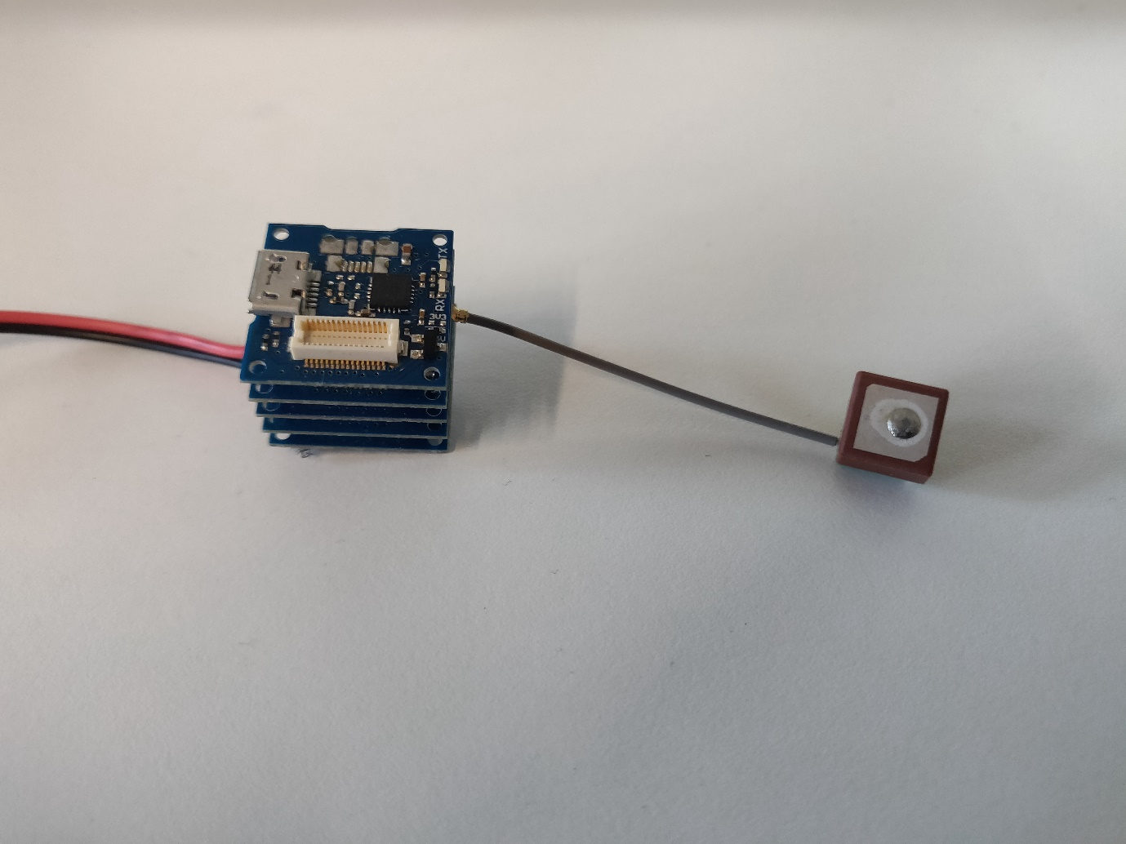

Figure 2: Measurement unit showing battery connection (left) and GPS sensor (right).

|  |  |  |
| --- | --- | --- |
| Device | Function |  |
| USB TinyShield ASD2131  <https://tinycircuits.com/products/usb-tinyshield> | Connect to computer via USB | https://cdn.shopify.com/s/files/1/1125/2198/products/ASD2101-R-Product-Picture-01_1800x1800.png?v=1577133357 |
| microSD TinyShield ASD2201  <https://tinycircuits.com/products/microsd-tinyshield> | Data storage on microSD | https://cdn.shopify.com/s/files/1/1125/2198/products/ASD2201-R-Product-Picture-01_1800x1800.png?v=1577129907 |
| 9-axis IMU TinyShield ASD2511  <https://tinycircuits.com/products/9-axis-imu-tinyshield> | Motion sensor – Gyro.: heave, pitch, and roll. Rate of heave, pitch and roll. Accel.: Acceleration in x, y and z. Mag.: Compass x, y and z. Pressure. Humidity. Light. Reads at approx. 20Hz. | https://cdn.shopify.com/s/files/1/1125/2198/products/ASD2511-R-N-Product-Picture-01_1800x1800.png?v=1577128085 |
| GPS TinyShield ASD2501  <https://tinycircuits.com/products/gps-tinyshield> | Geographical Positioning System: reads in NMEA sentences at approx. 1Hz. | https://cdn.shopify.com/s/files/1/1125/2198/products/ASD2501-R-Product-Picture-01_1800x1800.png?v=1577129196 |
| TinyDuino Processor Board ASM2001  <https://tinycircuits.com/products/tinyduino-processor-board> | Processor.  32KB Flash, 2KB RAM, 1KB EEPROM. 20mm x 20mm.  Max Height (without battery holder): 2.9mm. 1.10 grams. | https://cdn.shopify.com/s/files/1/1125/2198/products/ASM2001-R-L-Product-Picture-03_1800x1800.png?v=1577131370 |
| Lithium Ion Battery Pack  <https://shop.pimoroni.com/products/lithium-ion-battery-pack> | 6600mAh (to be tested for longevity)  3.7V | Lithium Ion Battery Pack |